Applied Discrete Modelling

Kanishk Kashayap, XxX Himanshoo, Atif Usman

Assignment- 3

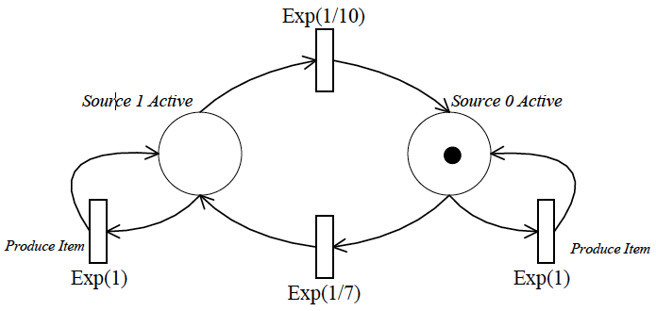

**System Specification:**

A quality tester’s behaviour is described by the above GSPN.

Assuming, that in each time step, one item is produced, the probability for the item to test OK is 0.9 for source 0 and 0.95 for source 1.

**Tasks and Questions:**

Construct the state space and ERG of the above model

Construct the CTMC representing the GSPNs behaviour

Use your program to answer the following questions:

* What is the throughput of the transition from source 0 to source 1 in steady state for different discretization time steps (e.g. 2, 1, 0.5, 0.25, 0.1)?
* What is the probability of the place *Source 1 Active* being empty in steady state for different discretization time steps (e.g. 2, 1, 0.5, 0.25, 0.1)?
* What is the throughput of source 1 in steady state?

**Task 01:** Construct the state space and ERG of the above model.

Sol: From the provided GSPN we see two places, “Source 0” and “Source 1” and one token that is distributed among two places.

So the state space for the given system will be: (1,0) (0,1). Which is token being in either of the two places.

ERG:

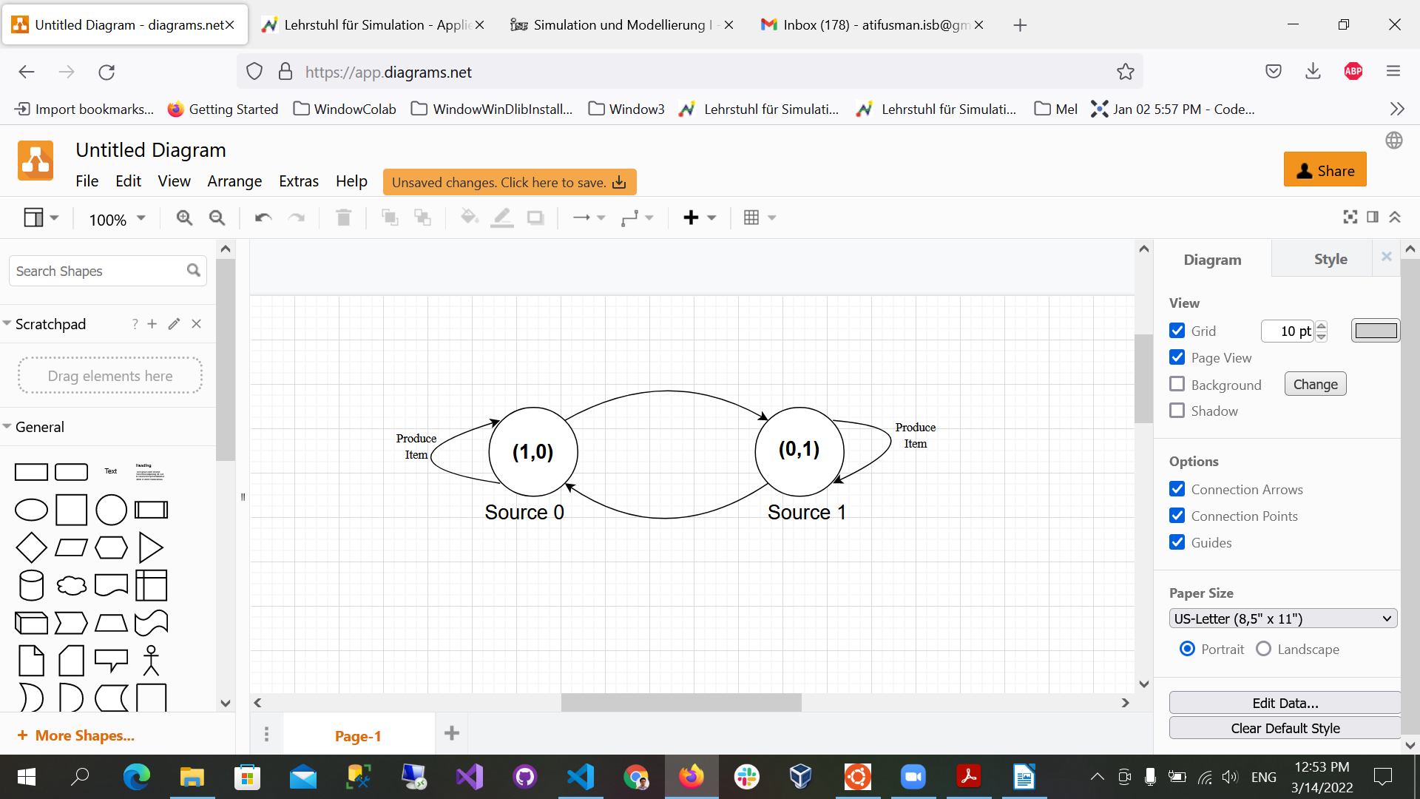

**Task 02:** Construct the CTMC representing the GSPNs behaviour.

Sol:

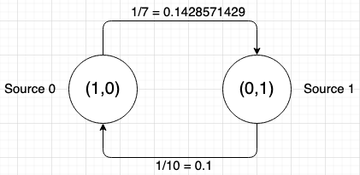

Since, CTMCs do not have self-transitions we only consider the transitions from one place to another.

**Task 03:** Programming questions

**3.1** What is the throughput of the transition from source 0 to source 1 in steady state for different discretization time steps (e.g. 2, 1, 0.5, 0.25, 0.1)?

Sol: Throughput is defined as the product of “place being active” and “flow rate”() where  = Exp(1/7).

|  |  |
| --- | --- |
| **Time Step** | **Throughput(P*)** |
| 2 | 0.1428571429*0.41152263 = 0.05878894716 |
| 1 | 0.1428571429*0.41152263 = 0.05878894716 |
| 0.5 | 0.1428571429*0.41152263 = 0.05878894716 |
| 0.25 | 0.1428571429*0.41152263 = 0.05878894716 |
| 0.1 | 0.1428571429*0.41152263 = 0.05878894716 |

**3.2** What is the probability of the place *Source 1 Active* being empty in steady state for different discretization time steps (e.g. 2, 1, 0.5, 0.25, 0.1)?

Sol:

|  |  |
| --- | --- |
| **Time Step** | **Probability of *Source 1* being empty** |
| 2 | 0.41152263 |
| 1 | 0.41152263 |
| 0.5 | 0.41152263 |
| 0.25 | 0.41152263 |
| 0.1 | 0.41152263 |

**3.3** What is the throughput of source 1 in steady state?

Sol: Throughput of source 1 in steady state is 0.3909465020576137.